Table of Contents
3. Aim of the Project 2
4. Objectives of the Project 2
5. Scope of the System 3
6. System Design and OOP Concepts 3
6.1 Classes 3
6.2 Citizen Class 3
6.3 PermitApplication Class 4
6.4 PermitSystem Class 4
6.5 Objects and Object Interaction 4
7. Python Data Structure 5
8. Methods Used in the Program 5
8.1 Instance Methods 5
8.2 Class Method 6
8.3 Static Method 6
9. Supported Permit and License Types 6
10. System Workflow 7
11. Application ID and Permit Number Generation 7
12. Digital Public Goods Alignment 7
12.1 Open Source 7
12.2 Inclusive and Accessible Design 8
12.3 Privacy-Respecting Design 8
12.4 Modular and Reusable Design 8
13. Government Domain and SDG 16 Alignment 8
14. Testing 9
15. Program Execution 10
16. Conclusion 13

1. Introduction
Government institutions issue permits and licenses to regulate different activities such as business operations, building and construction work, public events, trading, and other activities that require official authorization. When these records are handled manually, it can become difficult to organize applications properly, retrieve information quickly, and determine whether an application is pending, approved, or rejected.
Because of this challenge, I decided to develop the Smart Digital Permit and License Management System, a simple console-based Python application designed to demonstrate how Object-Oriented Programming (OOP) can be used to solve a real-world government-related problem
The system allows applicant information to be recorded, creates permit or license applications, generates a unique application ID, stores application records, allows application statuses to be updated, and provides functions for displaying and searching application information.
The project is intentionally limited to the concepts required by the assignment. These include classes, objects, attributes, methods, object interaction, one Python data structure, and Digital Public Goods principles. The purpose is therefore not to build a complete national permit platform, but to demonstrate how the required OOP concepts can be applied in a practical and understandable system.
2. Problem Statement
Before developing this project, I first tried to understand the challenges that may be faced by the main stakeholders involved in permit and license management, including government institutions, citizens, and other relevant partners.
Manual permit and license management can make it difficult to organize application records and track the progress of individual applications. Applicants and responsible officers may also experience difficulty determining whether a particular application is still pending, has been approved, or has been rejected when records are not properly organized or easily accessible.

Manual record-keeping can also make the process of searching for a specific application slower, especially when many applications are being handled. This may affect the efficiency of both applicants and officers responsible for managing the records.
There is therefore a need for a simple digital solution that can create and store permit or license applications, assign unique identification numbers, retrieve applications using their application IDs, update application statuses, and display application information in an organized manner.
The Smart Digital Permit and License Management System addresses this problem by providing a basic console-based system that demonstrates how OOP principles can be used to organize and manage permit and license application records more efficiently

3. Aim of the Project
The aim of this project is to develop a simple Digital Permit and License Management System using Python Object-Oriented Programming for creating, storing, searching, displaying and updating permit and license applications.

4. Objectives of the Project
- Create classes that represent a citizen, a permit application and the permit management system.
- Create objects from the defined classes and demonstrate interaction between objects.
- Use attributes to store applicant and application information.
- Use one Python dictionary to store multiple permit application objects.
- Allow a user to submit a new permit or license application.
- Generate a unique application ID for each new application.
- Allow an existing application to be searched by application ID.
- Allow the status of an application to be updated to Approved or Rejected.
- Demonstrate the use of instance methods, a class method and a static method.
- Develop the solution in line with the required Digital Public Goods principles.

5. Scope of the System
The system is limited to a console-based Python application and focuses only on the features needed to demonstrate the OOP concepts required by the assignment.
- Enter applicant information.
- Submit a permit or license application.
- Select one of four supported permit or license types.
- Generate a unique application ID.
- Store application objects in one dictionary.
- Search for an application using its application ID.
- Update an application status.
- Generate a permit number when an application is approved.
- Display all stored applications and the total number of applications.
The system does not include a database, graphical user interface, website, authentication, online payment, document upload, email notification, API integration or other advanced technologies because these are outside the scope of the assignment.

6. System Design and OOP Concepts

6.1 Classes
A class is a blueprint used to define the attributes and methods of objects. This system uses three classes: Citizen, PermitApplication and PermitSystem.

6.2 Citizen Class
The Citizen class represents the person applying for a permit or license. It stores the citizen ID, name, phone number and email address.
class Citizen:
def __init__(self, citizen_id, name, phone, email):
self.citizen_id = citizen_id
self.name = name
self.phone = phone
self.email = email

6.3 PermitApplication Class
The PermitApplication class represents one permit or license application. It stores the application ID, applicant object, permit type, application date, application status and permit number. Every new application begins with the status Pending.
class PermitApplication:
total_applications = 0
def __init__(self, application_id, applicant, permit_type, application_date):
self.application_id = application_id
self.applicant = applicant
self.permit_type = permit_type
self.application_date = application_date
self.status = "Pending"
self.permit_number = "Not Issued"

6.4 PermitSystem Class
The PermitSystem class manages the application process. It stores the application objects and provides methods for submitting, searching, updating and displaying applications.
class PermitSystem:
def __init__(self):
self.applications = {}

6.5 Objects and Object Interaction
An object is an instance created from a class. During application submission, the program first creates a Citizen object and then passes that Citizen object into a PermitApplication object. The PermitApplication object is then stored and managed by the PermitSystem object. This demonstrates interaction between objects.
citizen = Citizen(citizen_id, name, phone, email)
application = PermitApplication(
application_id,
citizen,
permit_type,
application_date
)

7. Python Data Structure
The project uses one Python data structure: a dictionary. The dictionary is used to store multiple PermitApplication objects, with the application ID acting as the key and the PermitApplication object acting as the value.
self.applications = {}
self.applications[application_id] = application
For example, APP001 can point to the application object belonging to the first applicant. The dictionary also makes it simple to search for an application using its unique application ID.
application = self.applications.get(application_id)

8. Methods Used in the Program

8.1 Instance Methods
Instance methods operate on a particular object and use the self parameter. The program uses instance methods to display citizen details, display an application, update application status, generate a permit number and perform the main permit-system operations.
def update_status(self, new_status):
self.status = new_status
if new_status == "Approved":
self.generate_permit_number()

8.2 Class Method
A class method works with the class itself rather than a single object. The get_total_applications method returns the total number of PermitApplication objects that have been created.
@classmethod
def get_total_applications(cls):
return cls.total_applications

8.3 Static Method
A static method belongs logically to the class but does not need to access a particular object or the class state. The validate_permit_type method checks whether the selected permit or license type is supported by the program.
@staticmethod
def validate_permit_type(permit_type):
if permit_type == "Business License":
return True
elif permit_type == "Building Permit":
return True
elif permit_type == "Event Permit":
return True
elif permit_type == "Trading License":
return True
else:
return False

9. Supported Permit and License Types
The system supports four simple application types:
- Business License
- Building Permit
- Event Permit
- Trading License
These types are sufficient to demonstrate the use of attributes, validation and object creation without extending the project beyond the assignment scope.

10. System Workflow
The basic system workflow is as follows:
- The program displays the main menu.
- The user selects Submit New Application.
- The program collects applicant information and creates a Citizen object.
- The user selects a permit or license type.
- The program validates the selected type.
- A unique application ID is generated.
- A PermitApplication object is created with the initial status Pending.
- The application object is stored in the dictionary.
- The user can search for the application, update its status or display all applications.
- If the application is approved, a permit number is generated automatically.

11. Application ID and Permit Number Generation
Each application receives a unique application ID based on the total number of applications created. The first application is APP001, followed by APP002, APP003 and so on.
number = PermitApplication.get_total_applications() + 1
application_id = "APP" + str(number).zfill(3)
When an application is approved, the program generates a permit number using a short code for the permit type and the application ID. For example, an approved Business License with application ID APP001 becomes BUS-APP001.

12. Digital Public Goods Alignment

12.1 Open Source
The Python source code can be made openly available so that it can be studied, reused and improved. The program is written using standard Python without dependence on proprietary software components.

12.2 Inclusive and Accessible Design
The application uses a simple numbered console menu and clear text instructions. The user can perform the main operations without requiring advanced technical knowledge or a complex interface.

12.3 Privacy-Respecting Design
The program collects only the basic information required to demonstrate the permit application process: citizen ID, name, phone number, email, permit type, application date and status. It does not request passwords, banking details, medical information or other unnecessary sensitive information.

12.4 Modular and Reusable Design
The program separates responsibilities into the Citizen, PermitApplication and PermitSystem classes. This makes the code easier to understand and allows individual classes and methods to be reused or modified without changing the entire program.

13. Government Domain and SDG 16 Alignment
Government Domain. The project falls directly within the government domain because it focuses on the management of permits and licenses issued by public authorities. The system demonstrates how a government service can be organized digitally by recording applicants, creating applications, tracking application status and issuing a permit number when an application is approved.
SDG 16 Alignment. The Smart Digital Permit and License Management System supports Sustainable Development Goal 16: Peace, Justice and Strong Institutions. In a simple academic context, the system promotes more organized, transparent and efficient public service delivery by giving each application a unique ID, keeping a clear status record and allowing applications to be retrieved consistently.
Scope Note. The SDG connection is included only as supporting context. The implementation remains within the assignment scope and does not add databases, online payments, web portals, authentication or other advanced technologies.

14. Testing
The program was tested using the main functions provided in the menu. The following table summarizes the expected results.
Test | Input/Action | Expected Result
Submit application | Enter valid applicant details and select a permit type | Application is created with a unique ID and Pending status
Search application | Enter APP001 | Application details are displayed
Approve application | Select Approve for APP001 | Status changes to Approved and a permit number is generated
Reject application | Select Reject for an existing application | Status changes to Rejected
Invalid search | Enter an ID that does not exist | Application not found message is displayed
Display all | Choose Display All Applications | All stored application objects are displayed
Display total | Choose Display Total Applications | The total number of created applications is displayed
Exit | Choose Exit | The program closes successfully

15. Program Execution
The following screenshots show the program running successfully and demonstrate the main application functions.

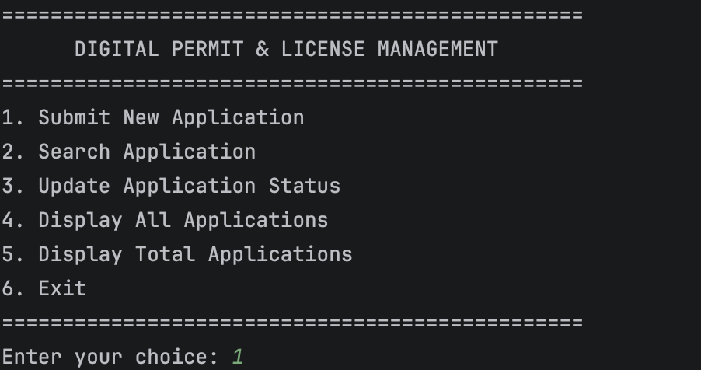

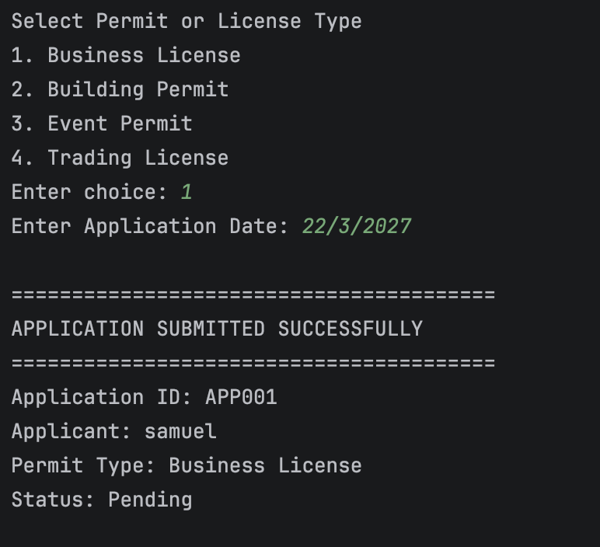

Figure 1: Main menu and successful submission of a new permit application.
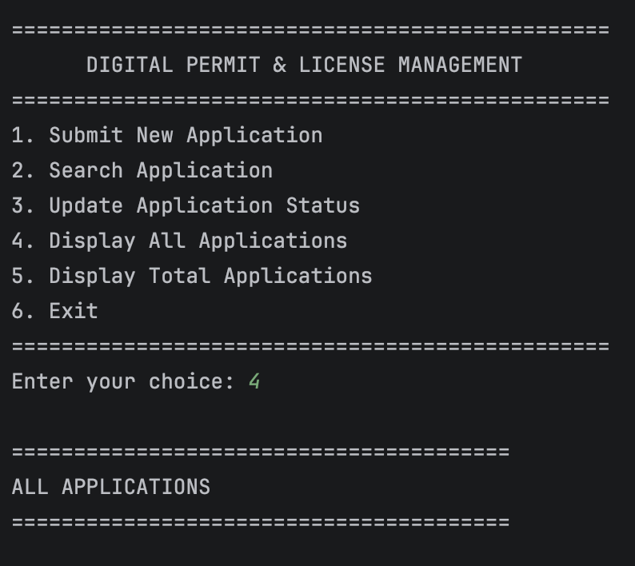

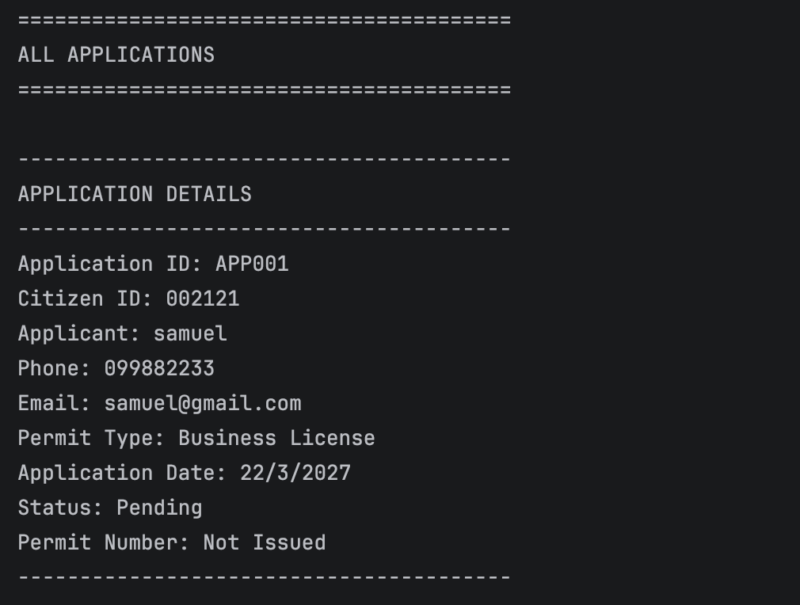

Figure 2: Searching for APP001 and displaying the stored application details.
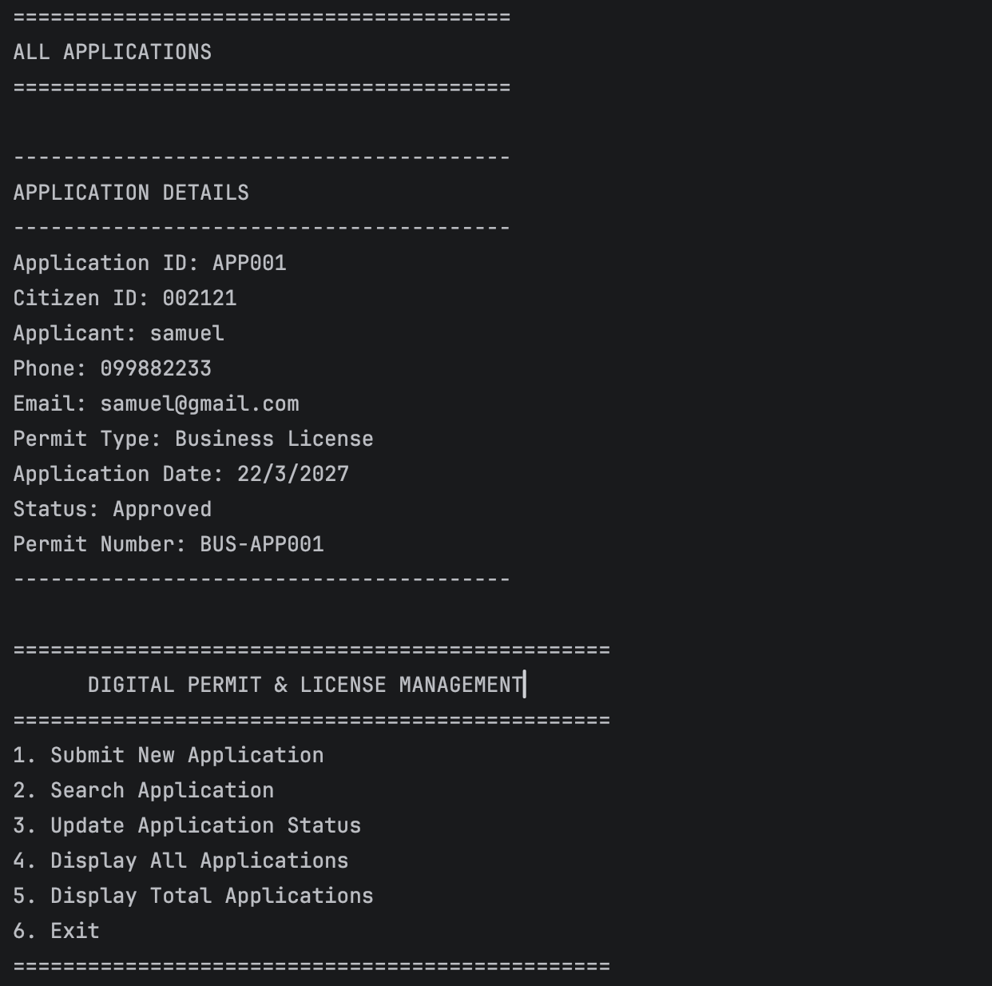
Figure 3: Approving the application and generating the permit number BUS-APP001.
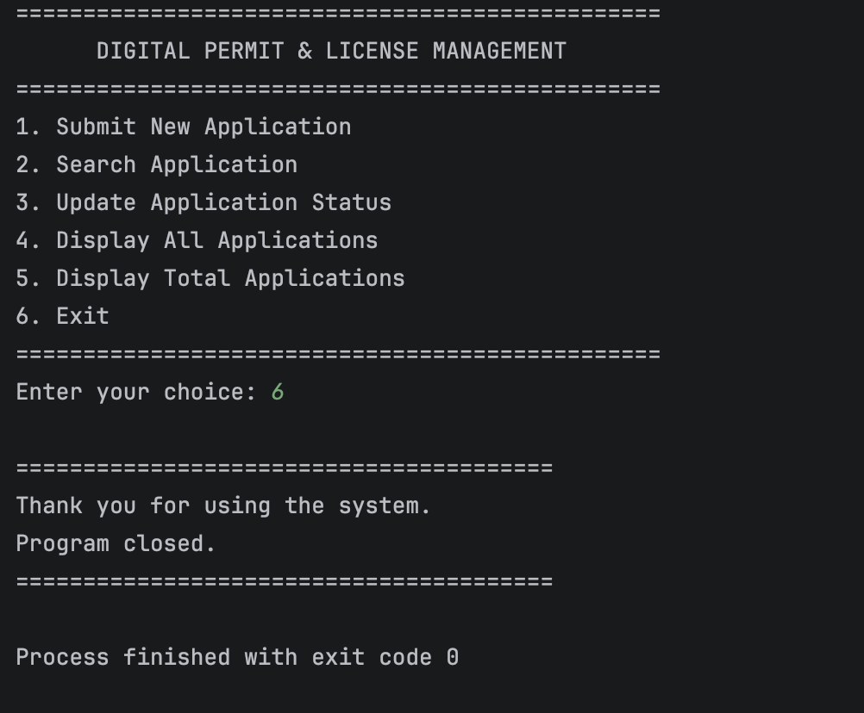
Figure 4: Displaying the approved status, total applications and successful program exit.

16. Conclusion
The Smart Digital Permit and License Management System demonstrates how Object-Oriented Programming can be applied to a simple real-world government problem. The program uses the Citizen, PermitApplication and PermitSystem classes to organize responsibilities clearly and demonstrates object creation and interaction between objects.
A single Python dictionary is used to store multiple application objects. The program also demonstrates instance methods, a class method and a static method. Users can submit applications, receive unique application IDs, search for applications, update application status, generate permit numbers for approved applications, display all applications and view the total number of applications.
The solution also follows the required Digital Public Goods principles by supporting open-source use, providing a simple accessible interface, limiting unnecessary personal information and using a modular class-based design. The project therefore remains within the stated assignment scope while demonstrating the required OOP concepts clearly. It also aligns with the government domain and supports SDG 16 by demonstrating a simple, structured approach to public permit and license administration.

